Employee Attrition Prediction using Machine Learning

Abstract
Employee attrition is one of the biggest challenges faced by organizations because it affects productivity, increases hiring costs, and reduces overall business performance. The aim of this project is to develop a Machine Learning model that predicts whether an employee is likely to leave the organization. The model is trained using employee-related information such as age, department, job role, monthly income, overtime, and years at the company. By predicting employee attrition in advance, organizations can take preventive measures to improve employee retention.

Introduction
Employee Attrition Prediction is a classification problem in Machine Learning. It helps organizations identify employees who are at risk of leaving the company. Predictive analysis enables HR departments to make better decisions regarding employee engagement, promotions, and retention strategies. In this project, Machine Learning techniques are applied to analyze employee data and predict attrition with good accuracy.

Objective
- To build a Machine Learning model for employee attrition prediction.
- To analyze employee data and identify factors affecting attrition.
- To achieve accurate predictions that can assist HR departments.
- To reduce employee turnover through data-driven insights.

Dataset Description
The dataset contains employee information such as Age, Department, Job Role, Monthly Income, Years at Company, Overtime, Education, and other important attributes. The target variable is Attrition (Yes/No). Before training the model, the data was cleaned, categorical values were encoded, and the dataset was divided into training and testing sets.

Machine Learning Model
A supervised Machine Learning classification model was trained using the processed dataset. The model learned patterns from historical employee data and predicted whether an employee would leave the organization. The model's performance was evaluated using Accuracy Score, Confusion Matrix, and Classification Report.

Results
The Machine Learning model achieved an accuracy of 86.73% indicating that it correctly predicted employee attrition for most employees in the testing dataset
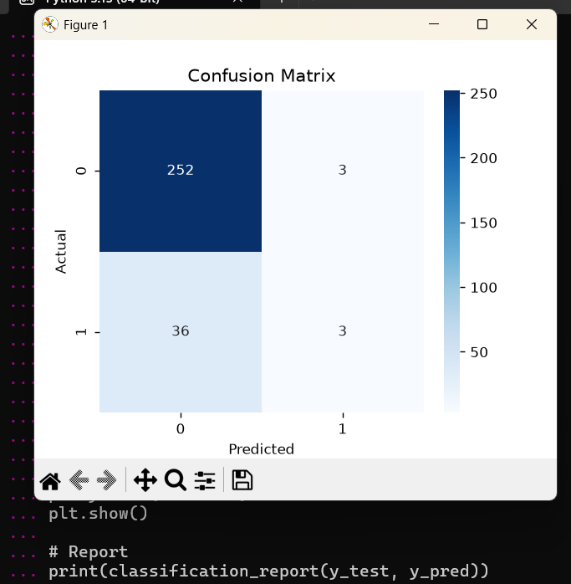

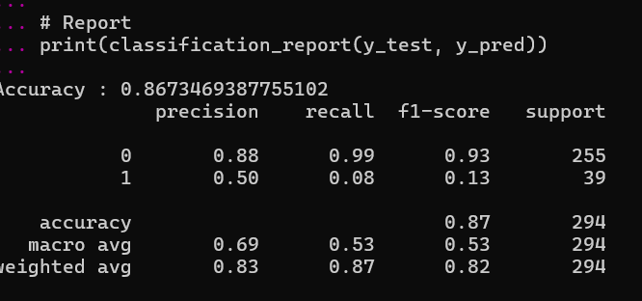

Conclusion

The Employee Attrition Prediction model successfully predicts employee turnover with good accuracy. The model can help HR departments identify employees who are likely to leave and take appropriate retention measures. This project demonstrates how Machine Learning can support data-driven decision-making in human resource management.

